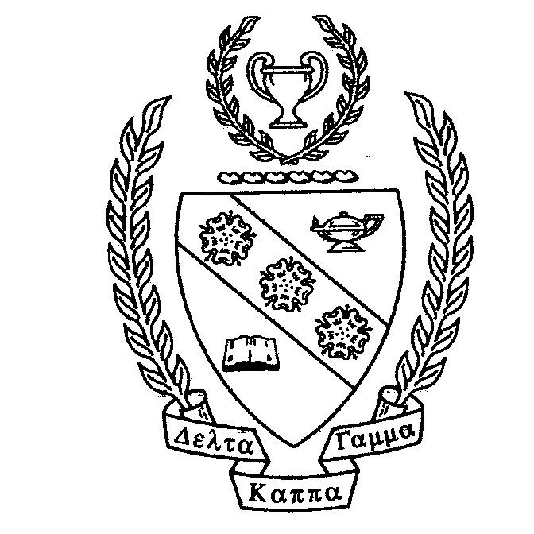

PRESIDENT’S MESSAGE
Dear Ladies,
You usually have a great message from President Gail. But this past Friday night (Nov 9) she was taken to St. Thomas Hospital in Nashville. She still has the stricture in her common bile duct. She will have an ERCP Scope to insert a stronger stent instead of surgery. She is still in St. Thomas (Nov 13) and is improving.
Martha

ALPHA PI OFFICERS 2018-2020
President: Gail Holland
First Vice President: Holly Calatrello
Second Vice President: Sharon Nelius
Secretary: Pam Williams
Treasurer: Rosie Graham
Related Personnel
Past President: Renee Flowers
Parliamentarian: Martha Scarbrough
Webmaster: Gail Holland

ALPHA PI MEETINGS 2018-2019
Wednesday, August 29 @ 4:00 pm
Tullahoma, 1st Christian Church Annex
Wednesday, September 19 @ 4:00 pm
Tullahoma, 1st Christian Church Annex
Saturday, November 17 @ 10:30 am
Tullahoma, One22West, 122 W Lincoln
December date TBA @ TBA
An extra activity just for fun!
Salvation Army Bell Ringer and
Meal at Tullahoma, La Fiesta
Wednesday, February 20 @ 4:00 pm
Tullahoma, 1st Christian Church Annex
Wednesday, March 13 @ 4:00 pm
Tullahoma,1st Christian Church Annex
Saturday, April 6 @ 10:00 am
Franklin County High School Library

DELTA KAPPA GAMMA

ALPHA PI NEWS
Biennium 2018-2020 Issue 3 Year 1
November 2018

“Explore, Dream, Discover…
Your Adventure Awaits!”

AGENDA November Meeting
Tullahoma, One122West
10:30 Call to Order
Devotional Thought
Brunch (cost $15.00)
Speaker: Dr. Elaine Alexander
Xi State President
Announcements
Initiation of New Members
12:30 Adjournment

ALPHA PI FACEBOOK GROUP
Be part of the Alpha Pi Facebook group: 1. Search for “Alpha Pi, Xi State DKG”
on Facebook.
2. Request to join. This is a closed
group so that only members who join
can see things posted.

ALPHA PI WEBSITE
www.alphapichaptertn.weebly.com

XI STATE NOTES
Vision Foundation Awards. The Xi State Vision Foundation provides funds for work and special projects that do not receive college credit but are related to the improvement of education. Applications must be submitted by December 1. Go to the Xi State website for more information.

DKG MISSION STATEMENT
The Delta Kappa Gamma Society International promotes professional and personal growth of women educators and excellence in education.
Alpha Pi Chapter Newsletter
November 2018
Page 2 of 2

A COUPLE OF RECIPES FOR
THANKSGIVING

SWEET POTATOE CASSEROLE
Thanks to Rebecca Langford
3 cups cooked, mashed sweet potatoes
1/4 cup butter
1/4 cup orange juice
1 cup sugar 1/4 cup milk
1/2 tsp. salt 2 eggs

Mix all ingredients together and pour into casserole dish. Cover with topping.

Topping:
1 cup brown sugar 1 cup chopped nuts
1/3 cup flour 1/4 cup butter
Mix thoroughly and sprinkle over potato mixture. Bake 35 minutes in a 350 degree oven.

GREEN BEANS SUPREME
Thanks to Pam Williams
2 (10 oz) packages frozen French style green beans
2 tablespoons butter
2 tablespoons flour
1/2 teaspoon salt
1 teaspoon sugar
1/4 teaspoon white pepper
1 tablespoon grated onion
1 cup sour cream
1/4 pound grated Swiss cheese
1 cup corn flakes, crushed
1 teaspoon melted butter
Cool beans until crisp; drain thoroughly. Melt butter over low heat; blend in flour. Add salt, sugar, pepper, and onion. Stir in sour cream until smooth and thickened. Remove from heat and fold in beans. Put in a 2 quart greased casserole. Sprinkle grated Swiss cheese over the top; cover with corn flakes and drizzle with 1 teaspoon melted butter. Bake at 350 degrees for 30 minutes. Serves 6.

HAPPY BIRTHDAY TO YOU!!
November
November 23 – Alice Huskey
December
December 25 – Virginia Davis

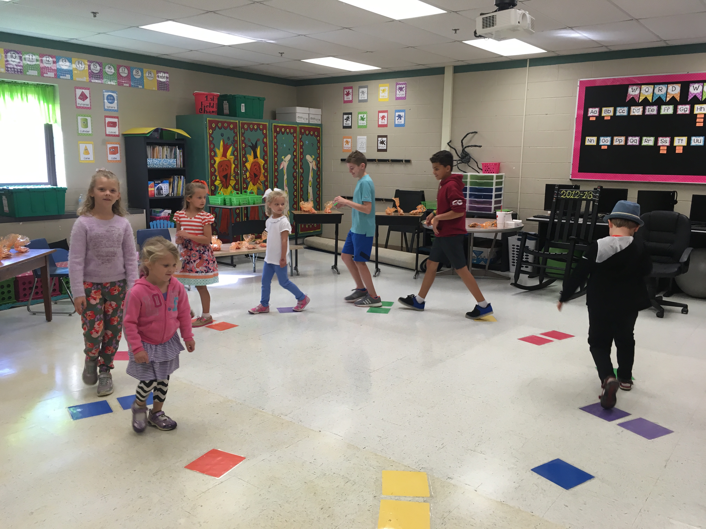
Fall Festival at
Robert E Lee Elementary School
Do you see Holly?
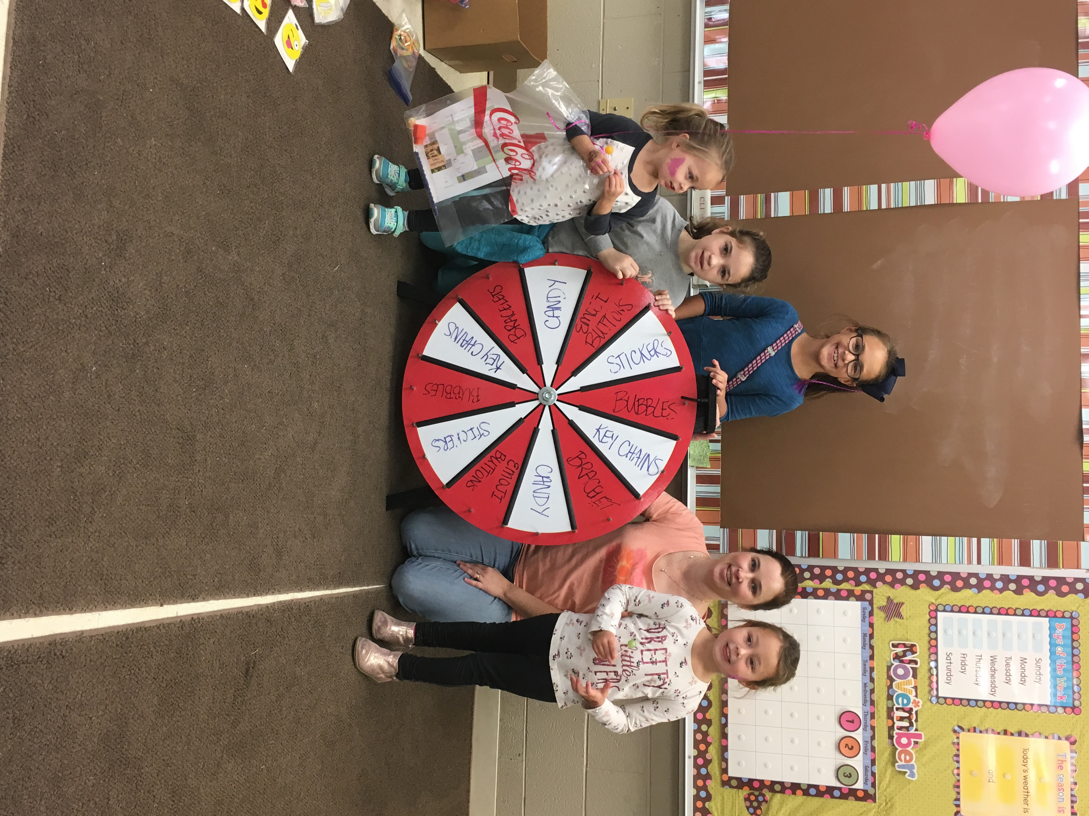

Below: Robert E. Lee Elementary
Veteran’s Day Program
Third graders are singing.

