PRESIDENT’S MESSAGE
Happy February Sisters!

I hope that you are enjoying all things winter...sweaters, boots, hot chocolate, snuggly blankets and maybe a good book or the Hallmark Movie Channel!

I am looking forward to seeing everyone at our next meeting at 4:00 pm on February 20! Chelle Daniels will be speaking to us with her program entitled, “Providing Opportunities and Enriching Lives Through Early Awareness and Sustained Exposure in Science, Technology, Engineering & Math.” She says the students in her STEM class have created something special for us!
(continued on page 2)
ALPHA PI OFFICERS 2018-2020
President: Gail Holland
First Vice President: Holly Calatrello
Second Vice President: Sharon Nelius
Secretary: Pam Williams
Treasurer: Rosie Graham
Related Personnel
Past President: Renee Flowers
Parliamentarian: Martha Scarbrough
Webmaster: Renee Flowers

ALPHA PI MEETINGS 2018-2019
Wednesday, August 29 @ 4:00 pm
Tullahoma, 1st Christian Church Annex
Wednesday, September 19 @ 4:00 pm
Tullahoma, 1st Christian Church Annex
Saturday, November 17 @ 10:30 am
Tullahoma, One22West, 122 W Lincoln
December 18 4:00 pm – 6:00 pm
Community Service activity for fun!
Salvation Army Bell Ringer @ WalMart
Meal at Tullahoma, La Fiesta @ 6:15
Wednesday, February 20 @ 4:00 pm
Tullahoma, 1st Christian Church Annex
Wednesday, March 13 @ 4:00 pm
Tullahoma,1st Christian Church Annex
Saturday, April 6 @ 10:00 am
Franklin County High School Library

DELTA KAPPA GAMMA

ALPHA PI NEWS
Biennium 2018-2020 Issue 5 Year 1
February 2019

“Explore, Dream, Discover…
Your Adventure Awaits!”

AGENDA February 20, 2019 Meeting
First Christian Church Annex,
Tullahoma
Hostesses: Renee Flowers
Pam Williams
4:00 Call to Order
Devotional – Renee Flowers
Program: “Providing Opportunities
and Enriching Lives Through Early
Awareness and Sustained Exposure
in Science, Technology, Engineering,
and Math”
Speaker: Chelle Daniels

Meeting Business
Minutes of November 2018
Treasurer’s Report
Committee Reports
Old Business
New Business
Announcements
6:00 Adjournment

NOMINATING NEW MEMBERS
Nominations for new members will be presented for voting at the February meeting. Let Joan Pockrus know of anyone that you would like to nominate.

ALPHA PI FACEBOOK GROUP
Be part of the Alpha Pi Facebook group: 1. Search for “Alpha Pi, Xi State DKG”
on Facebook.
2. Request to join. This is a closed
group so that only members who join
can see things posted.

ALPHA PI WEBSITE
www.alphapichaptertn.weebly.com

Alpha Pi Chapter Newsletter
February 2019
Page 2 of 2

PRESIDENT’S MESSAGE (cont.)
We will also be playing Bunco after the meeting so please join us for this fun and informational meeting!

Please take a few minutes and review the Delta Kappa Gamma Purposes. I love that our organization does so much to empower and support women educators!

Purposes
* To UNITE women educators of the world in genuine spiritual fellowship
* To HONOR women who have given or who evidence a potential for distinctive services in any field of education
*To ADVANCE the professional interest and position of women in education
*To INITIATE, ENDORSE, AND SUPPORT desirable legislation or other suitable endeavors in the interests of education and of women educators
*TO ENDOW scholarships to aid outstanding women educators in pursuing graduate study and to grant fellowships to non-member women educators
*To STIMULATE the personal and professional growth of members and to encourage their participation in appropriate programs of action
*To INFORM the membership of current economic, social, political and educational issues so that they may participate effectively in a world society

Keep in mind that registration for the XI State Convention will be coming soon. I would love to see many members from our chapter attend!

Best regards,
Gail

DKG MISSION STATEMENT
The Delta Kappa Gamma Society International promotes professional and personal growth of women educators and excellence in education.

Remembering Initiation November 2018
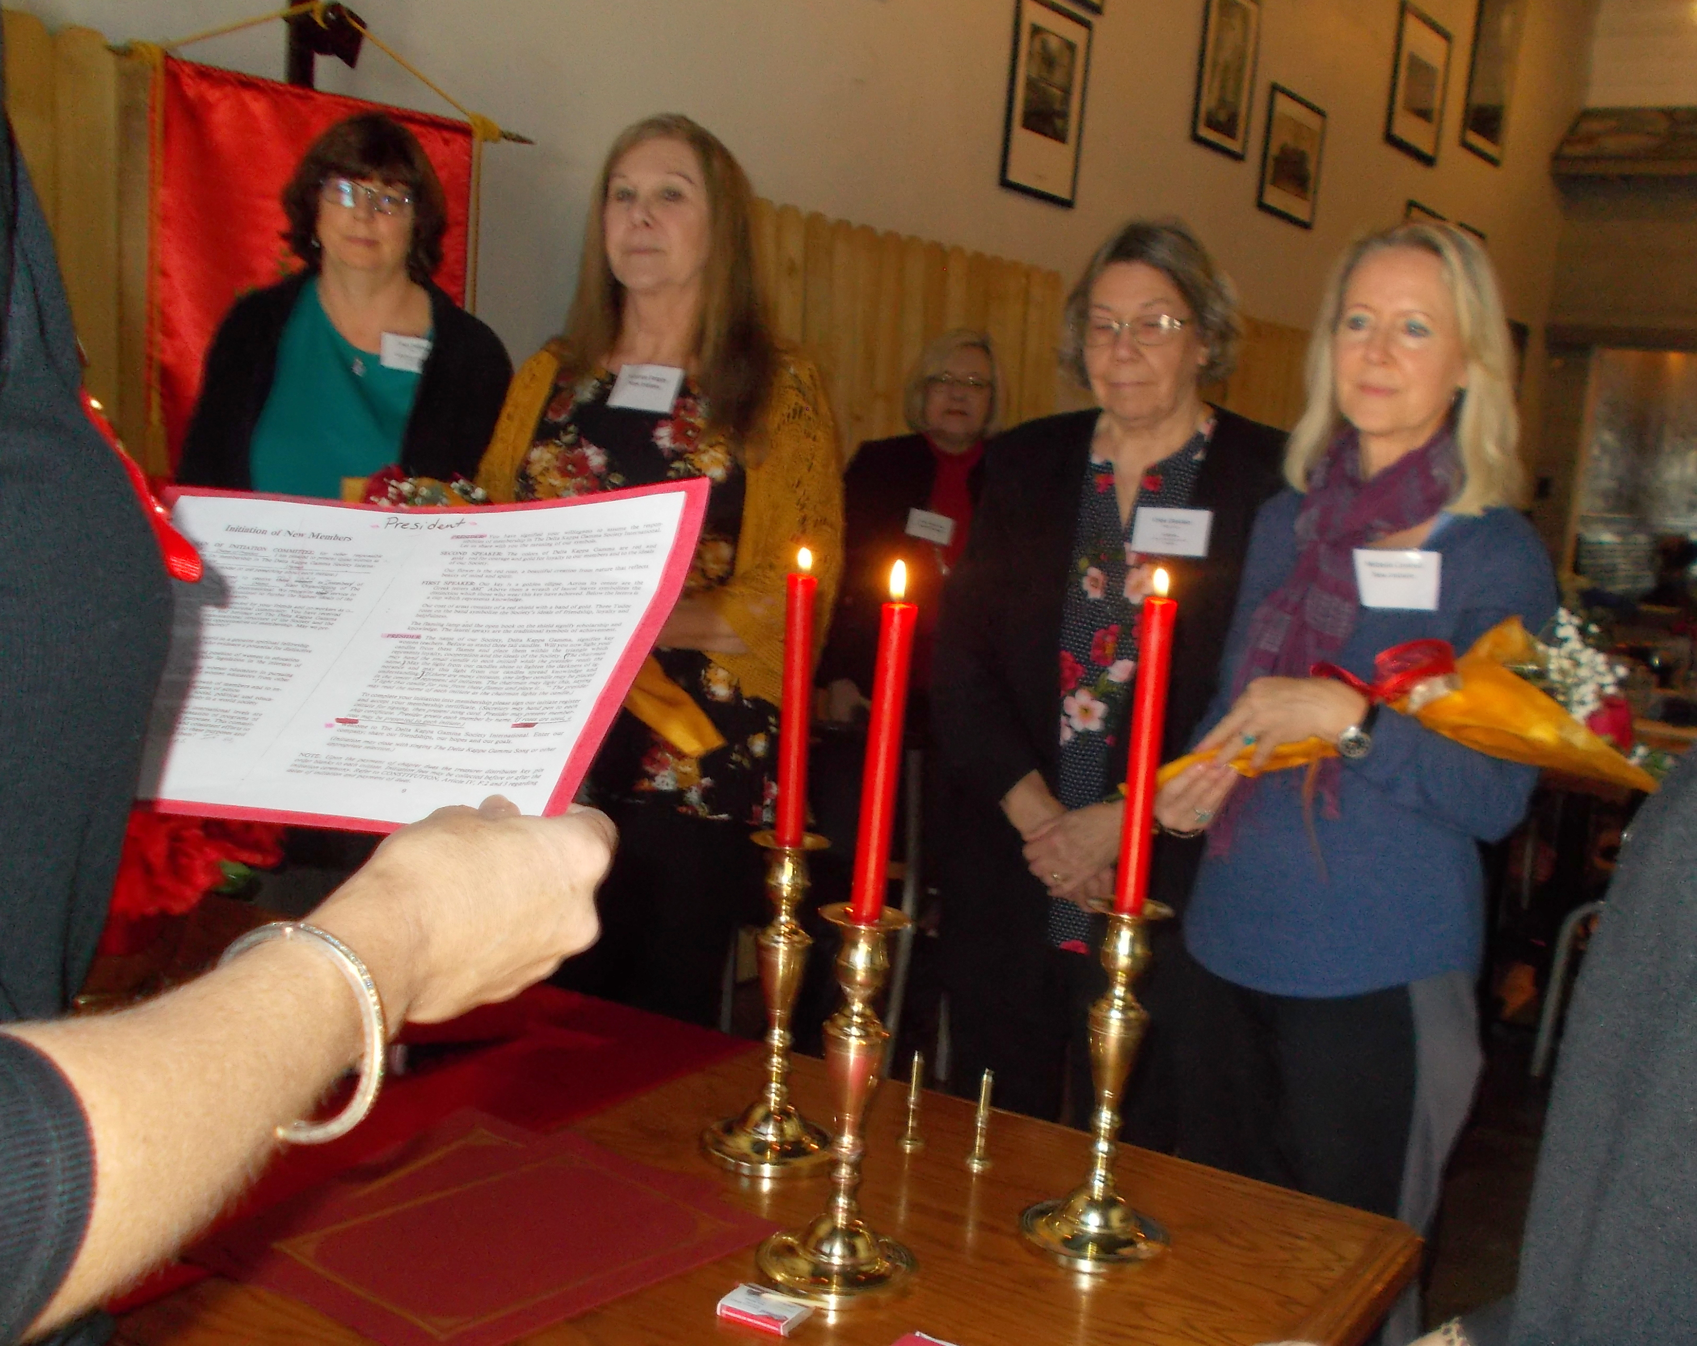
Welcome
Tammye Forgey and Michelle Cantrell
See information about Tammye and
Michelle in the member listing in the
2018-19 yearbook.

Thank you Sharon Nelius for this picture and the info about Farrar Elementary.
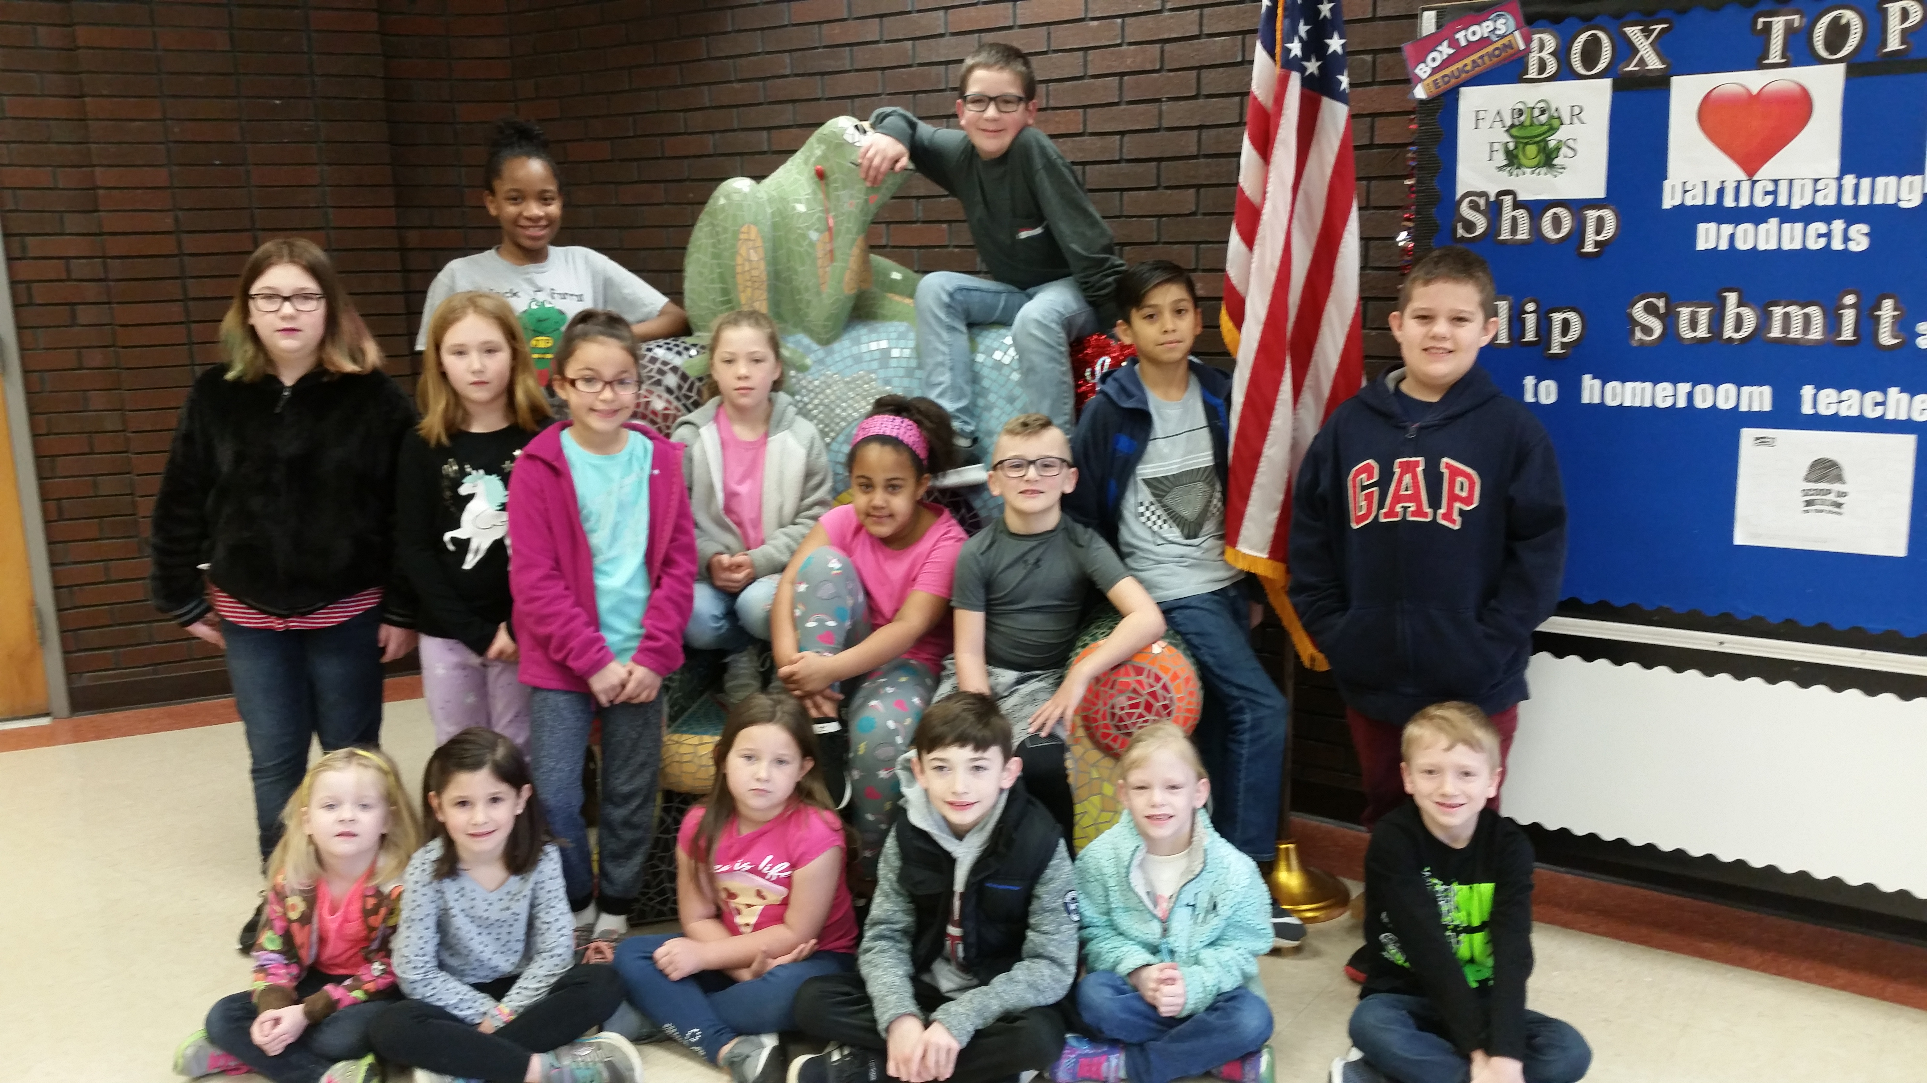
These students were chosen by their teachers for showing Fairness. This is part of Farrar Elementary's Character Education program.

XI STATE NOTES

XI STATE CONVENTION
Xi State Convention is scheduled for Thursday, May 30 thru Saturday, June 1, 2019. Look for registration form in the February issue of Xi State News and on the Xi State website.
SOUTHEAST REGION CONFERENCE
The 2019 Southeast Regional Conference will be held in Asheville, NC, June 27-29, 2019. The theme for the conference is the Arts and Humanities. Registration forms will be available later.

